User manual for our application.

Step 1: Press on the add symbol at the top right corner to create an event.

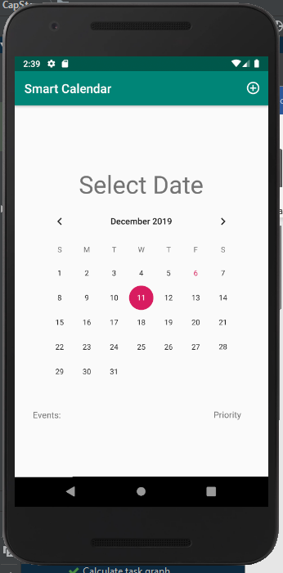

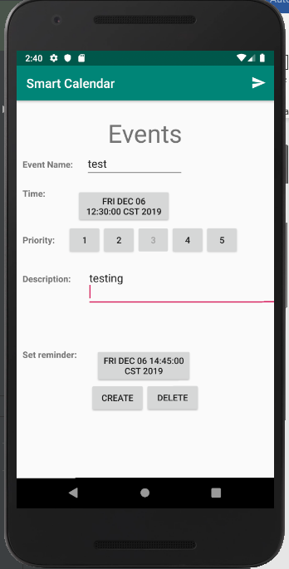Step 2: Add information about the event.

step 3: Press create at the button left to finish creating an event and add it to the database.

Step 4: your event is now added to the Database. The added event will be display below the calendar.

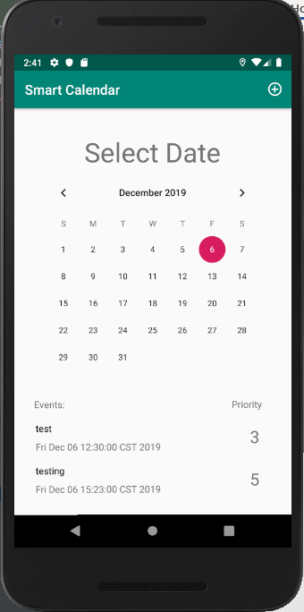

Step 5: To delete an event click on the event that you want to delete, and it will take you to a page where you’ve created the event. Once you are on that page click delete to delete an event from the database.



Step 6: your delete is now deleted and disapear from the screen below.

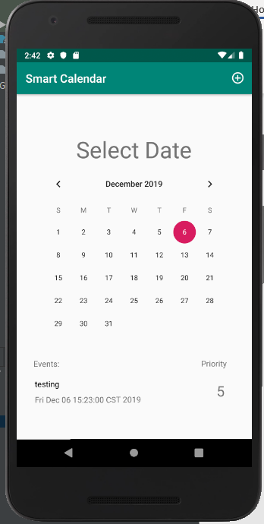

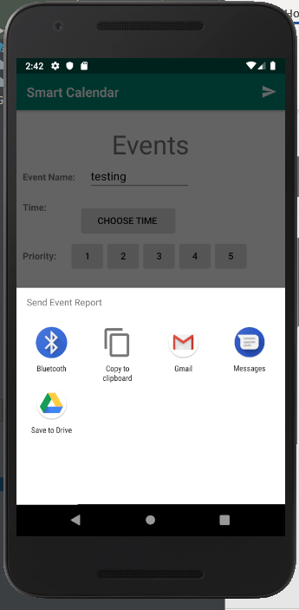Step 7: To send an event to your friends by message, email , etc. click on the arrow button and choose an application you would like to use to send the event.